TezKart Design System Documentation
Project Name: TezKart – Quick Commerce E-Commerce Platform

1. Introduction
The TezKart Design System defines the visual language, UI standards, reusable components, and styling guidelines used throughout the application.
The objective of this document is to ensure:
- Consistent UI Design
- Better User Experience
- Faster Frontend Development
- Reusable Components
- Professional Product Appearance

2. Primary Colors
Primary colors represent the TezKart brand identity and are used across major UI components.
Usage | Color Name | HEX Code
Brand Primary | Purple | #5B2EFF
Primary Dark | Deep Purple | #4520D9
Primary Light | Lavender Purple | #7A5CFF
Active State | Royal Purple | #6C3EFF

Used In
- Logo
- Navigation Menu
- Login Button
- Add To Cart Button
- Checkout Button
- Active Tabs
- Links

3. Secondary Colors
Secondary colors are used for supporting UI elements, notifications, and status indicators.
Usage | Color | HEX Code
Success | Green | #22C55E
Warning | Orange | #FF8A00
Error | Red | #EF4444
Information | Blue | #3B82F6
Discount Label | Bright Green | #16A34A
Rating Stars | Gold | #FACC15
Background | Off White | #F8FAFC
Card Background | White | #FFFFFF
Border Color | Light Gray | #E5E7EB
Secondary Text | Gray | #6B7280

Used In
- Discount Badges
- Order Status
- Product Ratings
- Error Messages
- Success Notifications

4. Typography

Heading Font
Font Family: Poppins
Font Weight: 600, 700

Usage
- Page Titles
- Section Headings
- Navigation Menus
- Product Categories

Body Font
Font Family: Inter
Font Weight: 400, 500

Usage
- Product Descriptions
- Forms
- Labels
- General Content

Font Sizes
Element | Font Size
Main Heading | 32px
Section Heading | 24px
Card Heading | 18px
Product Title | 16px
Body Text | 14px
Small Text | 12px

5. Button Styles

Primary Button

Specifications
- Background Color: #5B2EFF
- Text Color: #FFFFFF
- Border Radius: 8px
- Font Size: 14px
- Font Weight: 500
- Padding: 12px 24px

Hover Effect
- Background: #4520D9
- Scale: 1.03
- Transition Duration: 0.3s

Example Buttons
- Add To Cart
- Place Order
- Send OTP
- Checkout

Secondary Button

Specifications
- Background Color: White
- Border: 1px Solid #5B2EFF
- Text Color: #5B2EFF
- Border Radius: 8px

Example Buttons
- Buy Now
- View Details
- Edit Address

Buy Now Button

Specifications
- Background Color: #FF8A00
- Text Color: White
- Border Radius: 8px
- Hover Color: #E97800

6. Layout and Spacing Rules
Proper spacing improves readability and creates a professional user experience.

Global Layout
Component | Spacing
Page Margin | 24px
Section Gap | 32px
Grid Gap | 24px
Card Gap | 16px

Card Design
Property | Value
Padding | 16px
Border Radius | 12px
Background | White
Shadow | Soft Shadow

Product Card Spacing
Component | Spacing
Image to Title | 12px
Title to Price | 8px
Price to Button | 12px
Card Padding | 16px

Form Spacing
Component | Spacing
Label to Input | 8px
Input to Input | 16px
Section Gap | 24px
Button Margin Top | 20px

Header Layout
Component | Spacing
Header Height | 72px
Navigation Gap | 20px
Search Bar Padding | 12px
Logo Margin | 24px

7. Card Components

Product Card
Contains:
- Product Image
- Product Name
- Product Price
- Rating
- Add To Cart Button

Card Style
- White Background
- Border Radius: 12px
- Shadow Effect
- Hover Elevation Effect

8. Input Field Standards

Text Fields
Property | Value
Height | 44px
Border Radius | 8px
Border Color | #E5E7EB
Padding | 12px

Used In
- Login Forms
- Search Box
- Address Forms
- Checkout Forms

9. Shadow System
Shadow Level | Value
Small | 0px 2px 4px rgba(0,0,0,0.08)
Medium | 0px 4px 10px rgba(0,0,0,0.12)
Large | 0px 8px 20px rgba(0,0,0,0.16)

10. Design References
The TezKart Design System is inspired by:
- Zepto
- Blinkit
- Swiggy Instamart
- Modern E-Commerce Platforms

11. Deliverables Checklist
Deliverable | Status
Primary Colors Defined | Completed
Secondary Colors Defined | Completed
Typography Defined | Completed
Button Styles Defined | Completed
Spacing Rules Defined | Completed
Design References Added | Completed
Ready for GitHub Upload | Completed
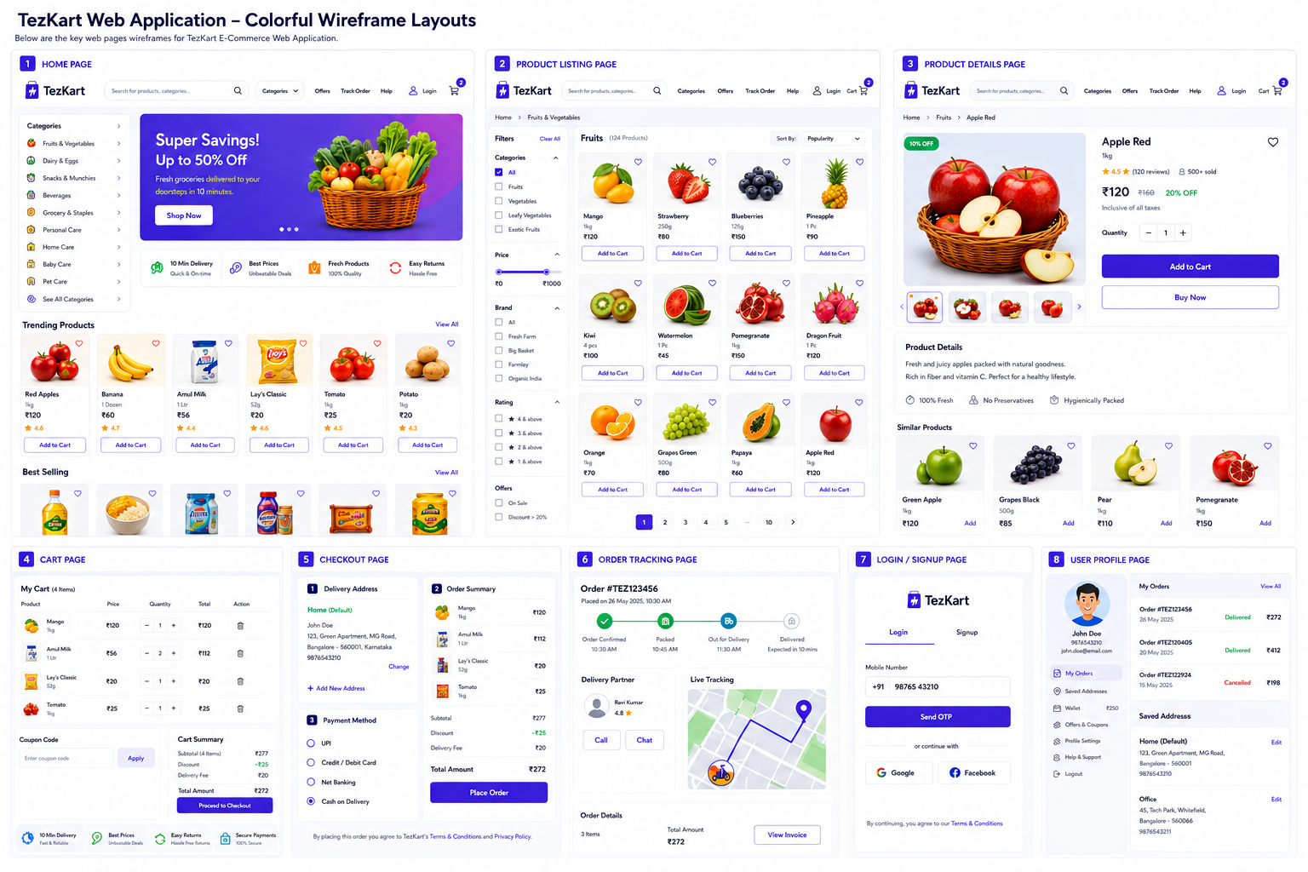

Conclusion
This design system establishes a consistent visual language for the TezKart platform. Following these standards will ensure uniform UI implementation, faster development, improved maintainability, and a better customer experience across all web pages.

